

Inventory planning module

Documentation

V3.2

Document Released: February 1, 2017

frePPLe bvba  
Woluwestraat 17  
1930 Zaventem  
http://frepple.com

**Table of Contents**

1. Introduction 3

2. User guide 3

a. Distribution planning screen 3

b. Inventory planning parameter report 9

c. Execution screen 10

3. Business processes and workflows 11

4. Configuration 12

5. Mathematical background 13

a. Reorder quantity 13

b. Safety stock 14

**The COMPLETE content of this DOCUMENT Is   
under copyright of frePPLE bvba.**

**distRIBUTIOn of this document is not allowed   
without explicit authorization from frePPLe BVBA.**

# Introduction

This document describes the inventory planning module of frePPLe. This module allows the calculation of the optimized reorder quantities and safety stocks for all buffers.

This is an important aspect of your planning process, as safety stocks are required to:

* Safety stocks are required to meet the expected service level of your customers.  
  When customer delivery times are shorter than the production or purchasing lead times, inventories are required to cover the expected demand over the lead time and its variability.
* Safety stocks covers for variability on the supply side.  
  Supplier purchasing lead times and manufacturing times have a level of variability that needs to be planned for to support a smooth progress of all activities.

This module computes these safety stock and reorder quantities, which are then used by the planning algorithm to generate matching replenishment plans.

# User guide

Three screens are used in the distribution planning workflows:

* Distribution planning screen
* Inventory planning parameter report
* Execution screen

## Distribution planning screen

The distribution planning screen provides a one-stop screen from which the user can conveniently perform the following actions:

* The top section of the screen allows to filter and sort item-locations according to planning metrics and various attributes.  
  Item-locations requiring attention are easily found.  
  The results can be shown in units or in monetary value, and in different time buckets (ie weeks, months, quarters or years).
* The bottom part has different tabs for different planning aspects.  
  Whenever a parameter is changed, you can hit the recalculate button to see the impact on the result.
* A first tab shows **the historical demand and the expected future forecast**.

The demand history in the past periods can be adjusted to remove exceptional demand outliers.   
Note that the adjustment is added to the actual history.

Example:  
A bucket has total demand of 2000 units. To eliminate an exceptional / one-of order of 1700 units from this history, you enter the value of -1700

The predicted forecast for the future periods can be adjusted if the planner has more information on the expected sales.   
Note that the manually entered forecast overrides / replaces the computed value completely.

Example:  
The system computes a forecast of 1500 units in a period. The planner can enter the value 2000 if he / she expects to sell 2000 units in that period.

The forecast and demand history adjustments can be entered at aggregated time buckets.

Example:  
The forecast for quarter 1 is 400, divided across months as: January 120, February 120 and March 160.  
If the planner edits the total value to 600, the results are disaggregated proportional to the original values: January 180, February 180 and March 240.   
If the original values would have been all 0, we will distribute equally: January 200, February 200 and March 200.

Below the forecast table, the planner can choose the forecast method for the item-location, and review the expected forecast error (evaluated using symmetric mean percentage error, aka SMAPE). After hitting the recompute button you can immediately see the updated forecast, inventory plan and replenishment transactions.  
  
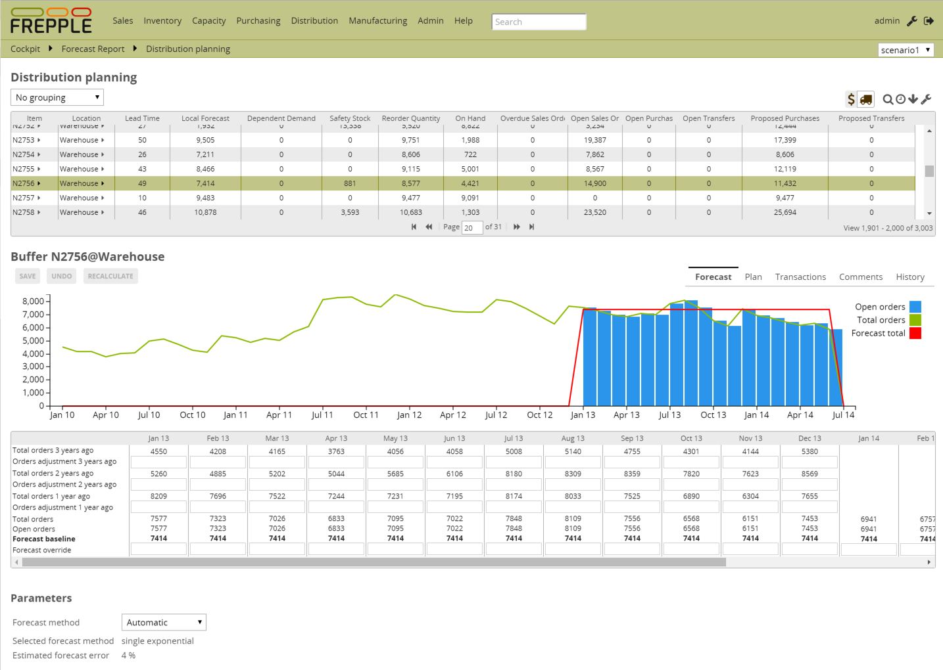

* A second tab shows the **planned inventory profile**.

Per period you can review the demand and supply. The reorder quantity and the safety stock are also displayed, and can be overridden in specific periods by the planner.

Below the plan table, the parameters affecting the inventory plan are displayed. You can change the parameter values, and hit the recompute button to immediately see the updated inventory plan and replenishment transactions.  
  
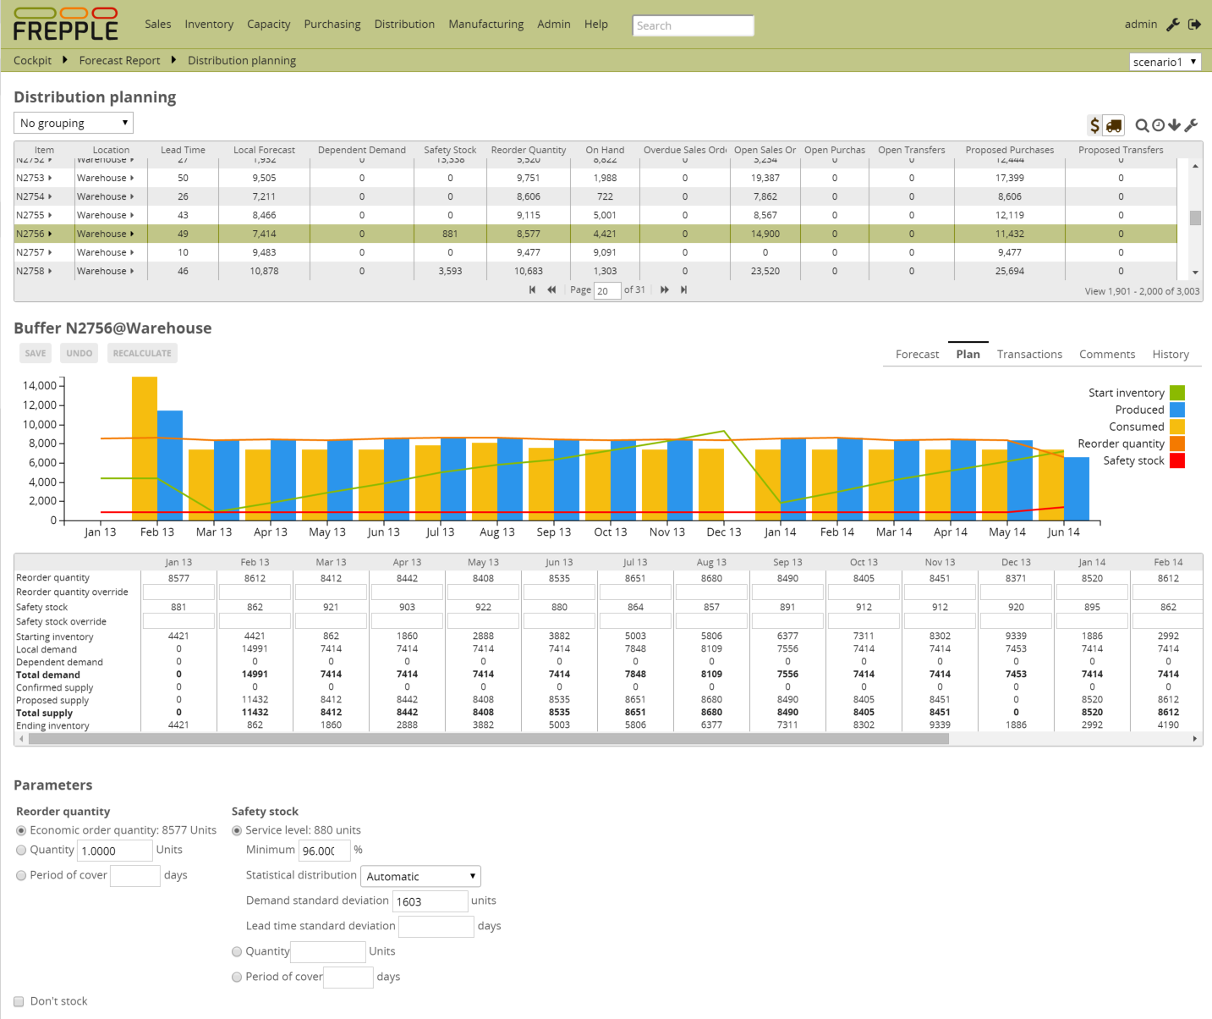  
  
Three methods are provided to compute the reorder quantity:

* + **Economic order quantity, computed by the system**  
    A reorder quantity can be computed that finds the best compromise between the cost of carrying inventory and the handling cost associated with each purchase order.  
    Check out the chapter on “mathematical background” to find more details.
  + **Fixed quantity**

This freezes the reorder quantity to a fixed value for all time periods.   
This can be useful eg when you order a pallet or a container at a time.

* + **Period of cover**Using this method the reorder quantity is computed to cover the expected demand for the specified time fence.

Since the demand varies over time, the reorder quantity will also vary for each period in the planning horizon.

Example:  
The period of cover is 70 days, while the demand is : January 120, February 120 and March 160.  
The resulting reorder quantity is computed as 297 = 120 (accounts for 31 days for January) + 120 (accounts for 28 days in February) + 160 * 11 / 31 (accounts for 11 days in March).

Three methods are provided to compute the reorder quantity:

* + **Service level, computed by the system**  
    The safety stock required to obtain a certain service level can be computed by the system.  
    Check out the chapter on “mathematical background” to find more details.
  + **Fixed quantity**This set a safety stock at a fixed value for all time periods.   
    This can be useful eg when you order a pallet or a container at a time.
  + **Period of cover**Using this method the safety stock is computed as the expected average demand over a specified time fence.  
    Since the demand varies over time, the safety stock will also vary for each period in the planning horizon.

As a special case users can flag certain item-locations to be **non-stockable**. The safety stock is then set to 0, and the reorder quantity is set to 1.  
Note that this flag does NOT mean the item can’t have any demand. If there is demand on a buffer with this flag set, we will create a replenishment plan where each demand has a matching supply of the same quantity on the same day.

* The third tab shows the **planned and ongoing transactions** that are currently ongoing or proposed by frePPLe. The list shows purchase orders, incoming distribution orders and outgoing distribution orders.

Date, quantity, item and supplier can be edited for proposed transactions.

When one or more rows are selected, the action list becomes active which is used to change the status of the transaction.

If the Openbravo connector app is activated, the dropdown allows the planner to immediately export the transaction immediately towards Openbravo.  
  
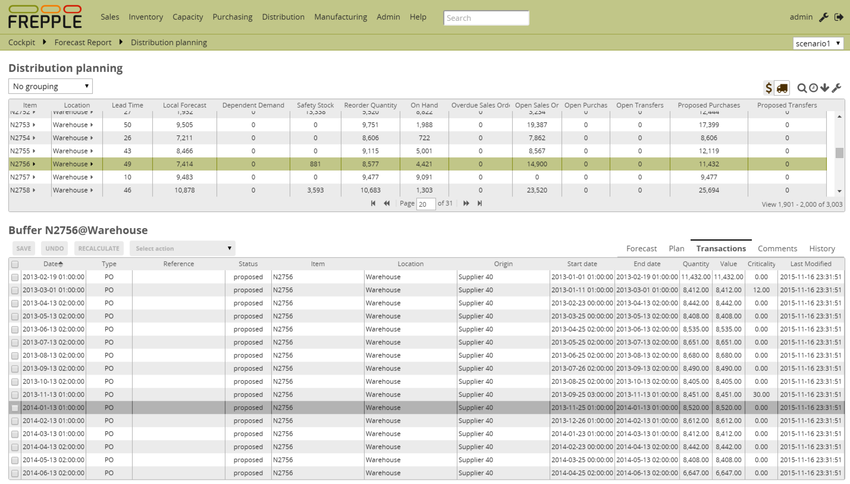

* A next tab shows **free-text comments** on the item, location and item-location. New comments can be added.  
    
  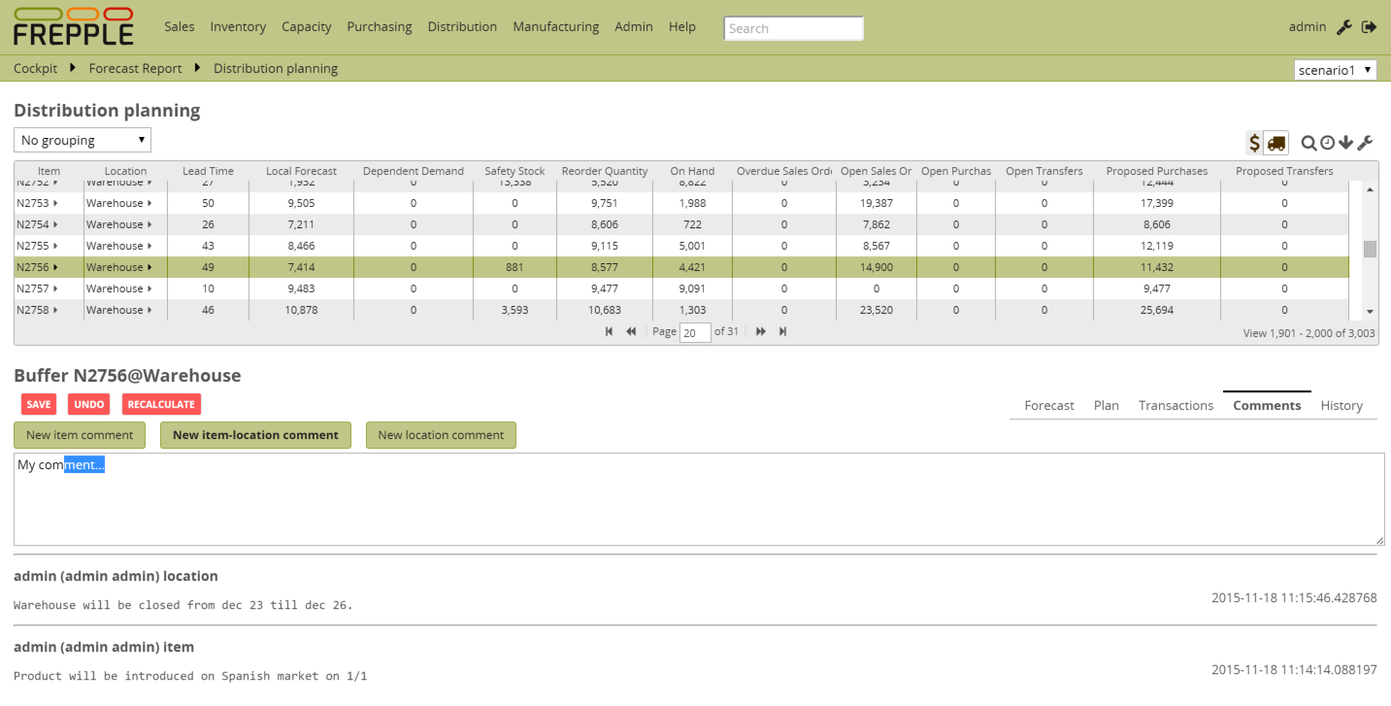
* The last tab shows the **editing history** of the item, location and item-location.  
    
  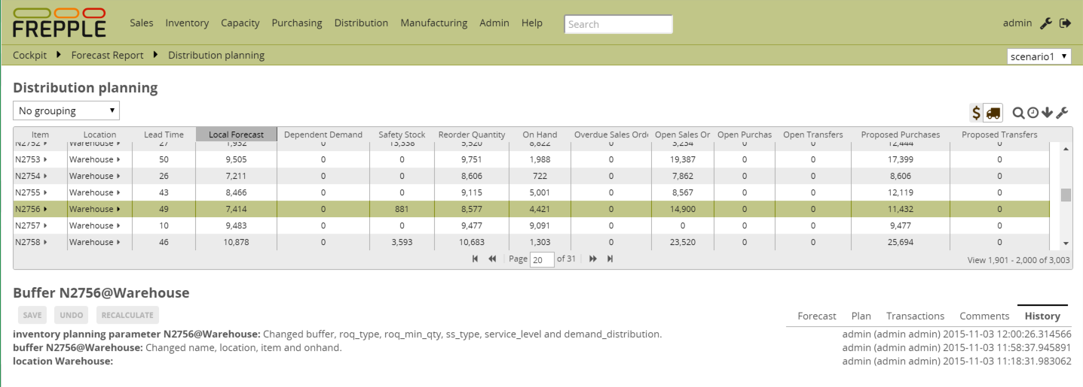

## Inventory planning parameter report

This report allows easy mass-maintenance of all inventory planning parameters.

You can directly edit the values in the data grid. Alternatively you can upload them as an excel spreadsheet.

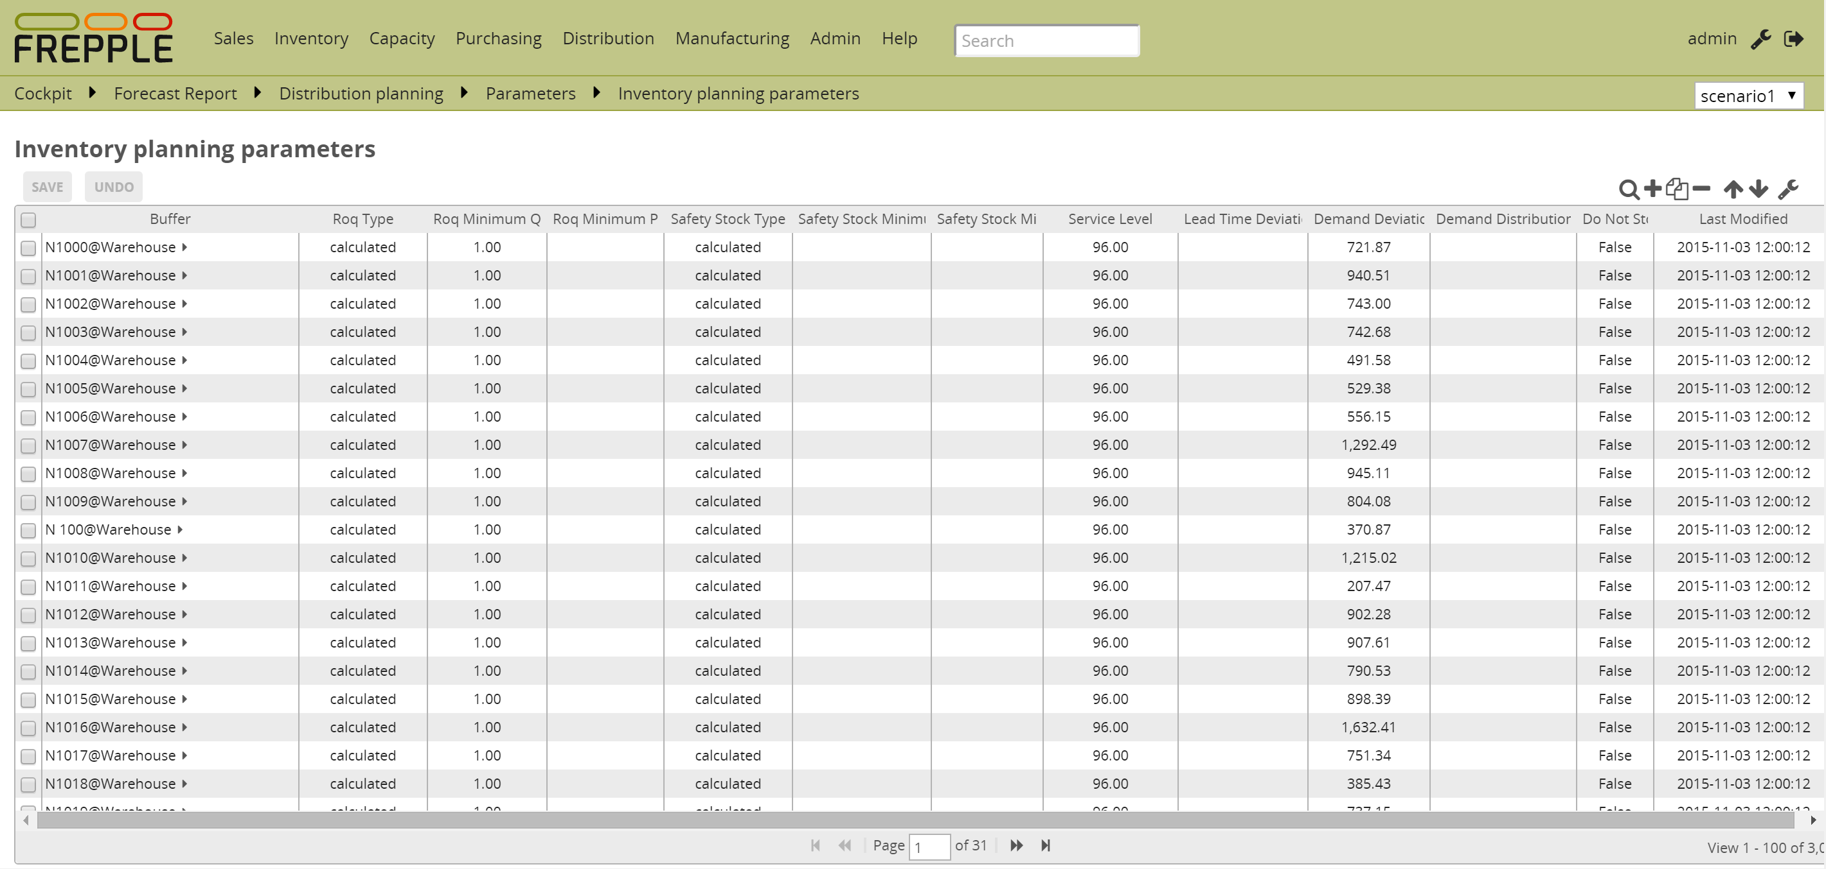

## Execution screen

The execution screen has an extra option in the plan generation task:

* **Compute inventory parameters**

This task calculates the reorder points and safety stocks.   
It is common to run different planning cycles.

* **Generate inventory rebalancing requests**  
  This task calculates the rebalancing requests (also known as transshipments). A rebalancing request is a distribution order that proposes to send back some extra stock to the source location if some criteria are met (see configuration section below). For a given item, a rebalancing request can only be created from a location B to a location A if there exists an item distribution record for that item from location A to location B.  
  There are 3 other conditions to respect to have a rebalancing proposed distribution order created:  
  - The price of the item must be greater than the value of parameter inventoryplanning.rebalancing_part_cost_threshold. This parameter prevents frePPLe from generating rebalancing requests for low-price items.  
  - The total price of the distribution order (item price multiplied by the quantity) must be greater than value of parameter inventoryplanning.rebalancing_part_cost_threshold. This parameter prevents frePPLe from generating rebalancing requests if the total price of the extra stock to send back is not important enough.  
  - The rebalanced quantity should not be consumed in less than x periods in the source location of the rebalancing request (based on the forecast at that location). This prevents frePPLe from generating rebalancing requests for amounts of stock that will be quickly consumed in the source location.

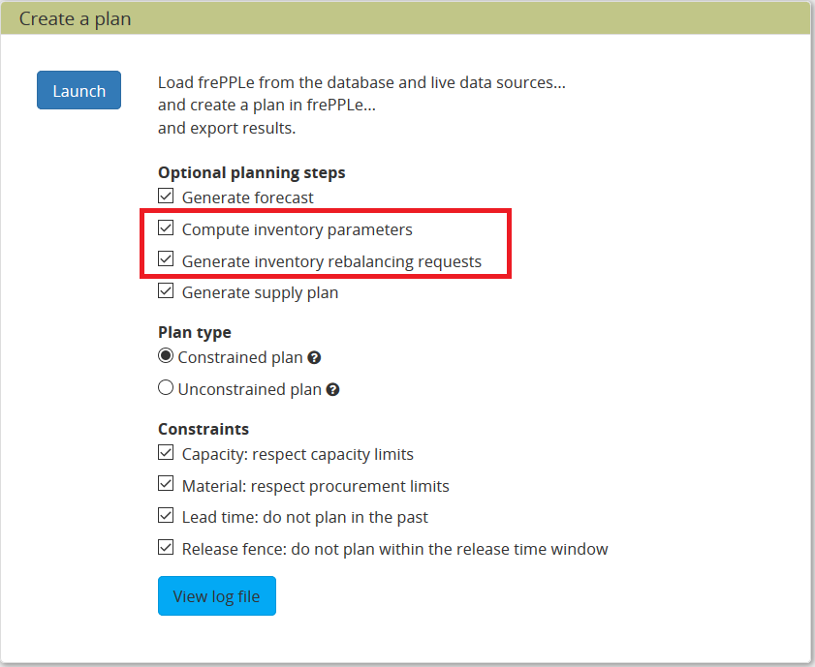

# Business processes and workflows

Calculating reorder quantities and safety stocks can be run as a separate planning process or integrated with a daily plan generation process.

For small organizations a single process that recomputes the complete plan will be most common.

For larger organizations where inventory is a strategic decision, it may be better to separate the planning processes:

* + In a **monthly planning cycle** the forecast and inventory planning parameters are computed by the system and reviewed by the planners. This process will tie into the Sales and Operations Planning process (aka S&OP) that generates a medium-term plan for the entire company.
  + A **daily planning cycle** will create production plans with the forecast and inventory planning parameters set earlier in the monthly cycle.  
    This cycle generates the purchase orders, distribution orders and manufacturing orders to realize the agreed plan.

# Configuration

The following extra parameters are introduced by this module.

|  |
| --- |
| **Parameter inventoryplanning.calendar:** Name of a calendar model to define the granularity of the time buckets for inventory planning.  This parameter is mandatory.  The calendar needs to have a specific structure:   * The parameter forecast.calendar needs to have the same value. A mismatch will result in unintuitive planning results. * It needs a calendar bucket for every bucket. * The start and end date of subsequent buckets must match exactly without any time gap in between. |
| **Parameter inventoryplanning.fixed_order_cost:** Fixed order cost to compute the economic reorder quantity.  Default value: 20 |
| **Parameter inventoryplanning.holding_cost:** Holding cost percentage to compute economic reorder quantity.  Holding cost percentage to compute economic reorder quantity.Default value: 0.05 |
| **Parameter inventoryplanning.horizon_end:** Specifies the number of days in the future for which we generate safety stock and reorder quantity values.  Default: 365 |
| **Parameter inventoryplanning.horizon_start:** Specifies the number of days in the past for which we generate safety stock and reorder quantity values.  Default: 0 |
| **Parameter inventoryplanning.loglevel:** Controls the verbosity of the inventory planning solver.  Accepted values are 0(silent - default), 1 and 2 (verbose) |
| **Parameter inventoryplanning.rebalancing _burnout_threshold:** The minimum time to burn up excess inventory (compared to forecast) that can be rebalanced (in periods). If the burn out period (Excess Quantity/Forecast) is less than the threshold, the rebalancing will not occur. Default value: 0 |
| **Parameter inventoryplanning.rebalancing _total_cost_threshold :** The minimum total cost threshold to trigger a rebalancing (equals to rebalanced qty multiplied by item price). Rebalancing requests with total cost below the threshold will not be created. Default value: 0 |
| **Parameter inventoryplanning.rebalancing_part_cost_threshold :** The minimum part cost threshold used to trigger a rebalancing. Parts with cost below the threshold will not be rebalanced. Default value: 0 |
| **Parameter inventoryplanning.service_level_on_average_inventory :** Flag whether the service level is computed based on the expected average inventory. When set to false the service level estimation is based only on the safety stock.  Default value: false |

# Mathematical background

In this section we describe the mathematical concepts behind the automated calculation of the reorder quantity and safety stock.

## Reorder quantity

The suggested reorder quantity is computed with the classic Wilson formula.

The computed value represent an optimal balance between the cost of carrying inventory in your warehouse and the costs associated with each order. If the order quantity gets larger, the costs of carrying inventory in the warehouse will grow. And if the order quantity gets smaller, the ordering frequency goes up and all costs associated with the handling of an order.

In which:

* D: annual forecast quantity
* K: fixed cost per order, which covers the shipping cost, handling costs and administrative time that are incurred with every order
* H: annual holding cost per unit, also known as carrying cost or storage cost

See <https://en.wikipedia.org/wiki/Economic_order_quantity> for more background.

## Safety stock

The safety stock is computed to reach a specified service level.

The calculation is based on the following elements:

* **Supply lead time of the item**The safety stock is calculated based using the smallest of a) the replenishment lead time and b) the period covered by reorder quantity (ie = reorder quantity / forecasted demand).  
  The second term accounts for item-locations with multiple open replenishments during the replenishment lead time.
* **Average expected forecast over the supply lead time**.  
  This is computed by frePPLe’s forecast module.
* **Standard deviation of the forecast over the supply lead time**.  
  FrePPLe’s forecast module also computes the expected standard deviation between the forecast and the actual demand.  
  The 2 examples below have the same average forecast. The item-locations with the higher volatility obviously will require a higher safety stock to provide the same service level.  
  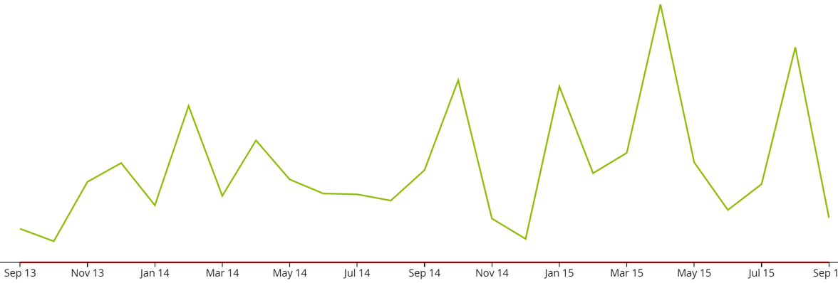

Figure 1 Item-location with a highly volatile demand pattern

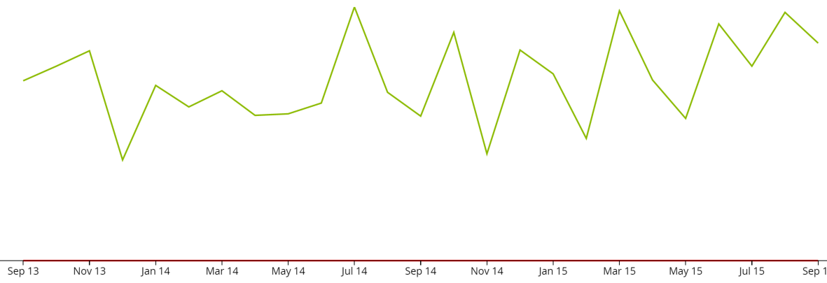

Figure 2 Item-location with a (relatively) stable demand pattern

* **Standard deviation of the lead time**.  
  In the same way as the demand is variable, also the supply lead time can be variable. This also results in a higher safety stock need.  
  This input value is provided as input data to frePPLe.
* **Statistical distribution to be applied on the forecast**  
  Based on the expected total demand over the lead time and its variability, frePPLe will fit a statistical distribution.  
  We will automatically select from:  
  + **Normal / Gaussian distribution**Used for all fast-moving items.  
    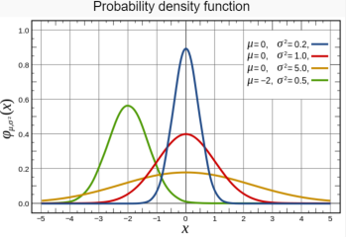  
    *Figure 3Normal distribution*

See <https://en.wikipedia.org/wiki/Normal_distribution>

* + **Poisson distribution**Used for slow movers.  
    This distribution is typical for slow moving spare parts: if the probability of a part failure is constant, the number of failures in a certain period is distributed according to a Poisson distribution.  
    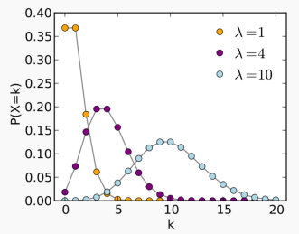  
    *Figure 4Poisson distribution*  
    See <https://en.wikipedia.org/wiki/Poisson_distribution>
  + **Negative binomial**Used for slow movers with a highly variable demand pattern.  
      
    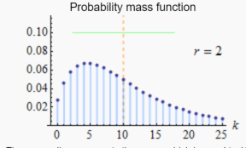  
    *Figure 5Negative binomial distribution*

See <https://en.wikipedia.org/wiki/Negative_binomial_distribution>

Combining all the above we can establish the translation curve between the safety stock and service level. Given a desired service level, we can use it to look up the required safety stock level to reach it. Given a certain inventory level, we can use it to look up the service level we can expect it to provide.

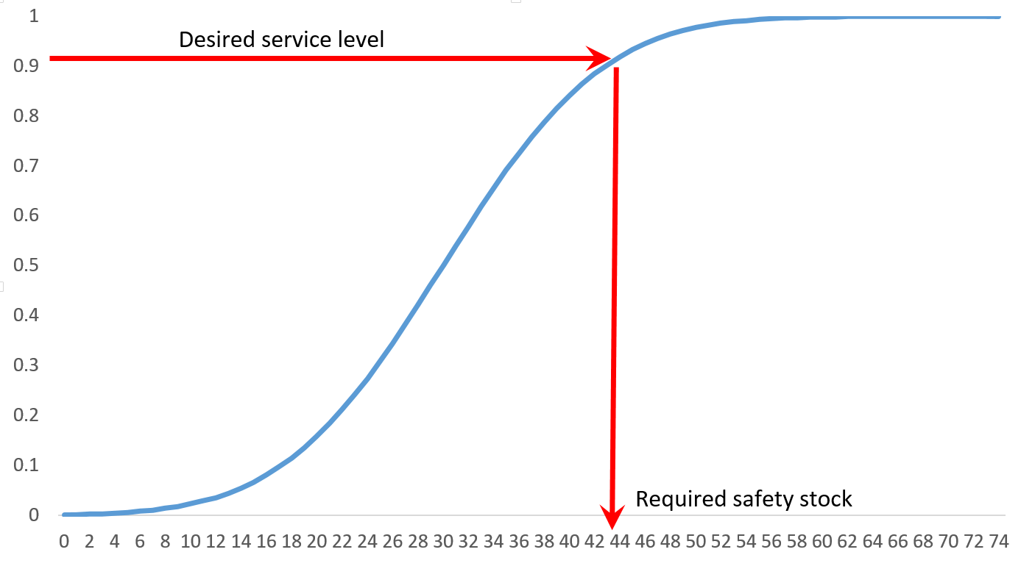

Figure 6 Translating between service level and safety stock

The calculation can be done considering the average inventory (= safety stock + half of the reorder quantity), or considering only the safety stock.   
An example to illustrate the difference:

* Imagine an item for which the reorder quantity represents 1 year of forecasted demand
* If the service level is computed on the average inventory:  
  The service level will be very high, even if the safety stock is 0. Because of the high reorder quantity, we’ll have less than 1 stockout per year.  
  The service level represents the total service we plan for towards customers.
* If the service level is computed on the safety stock only (default setting):  
  The safety stock level will be higher and be more realistic to actually avoid stockouts.   
  The service level should be interpreted as a stockout probability in this case, as we only consider only the lowest stock level.   
  The service level towards customers will be higher.

The correct interpretation is important when specifying the service level in frePPLe.